- \Operation\Colling Water\Setting
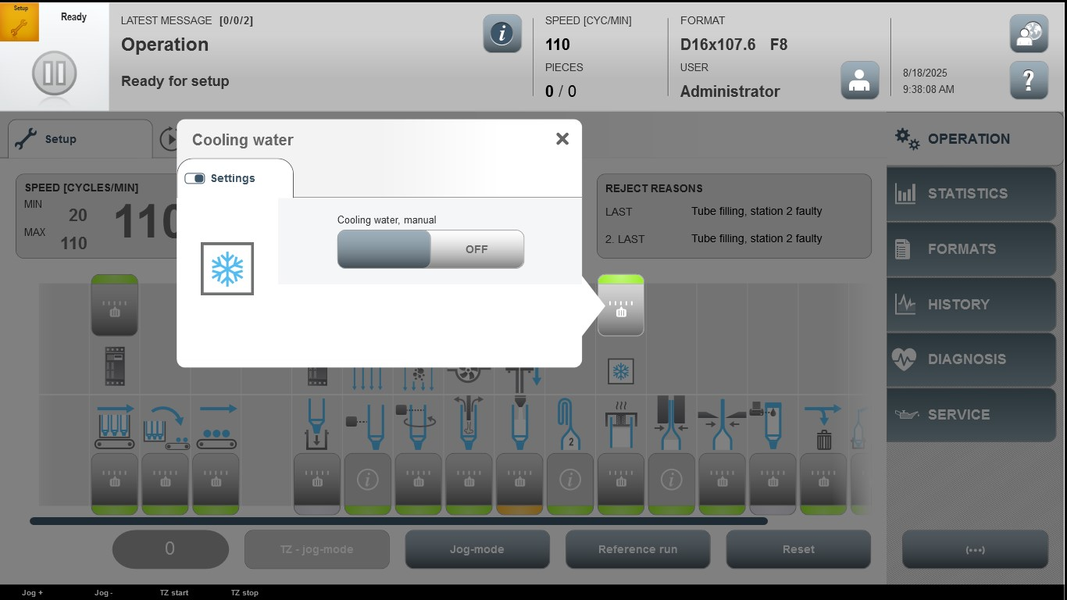

Acceptance criterion | Limits | Pass / Fail: Dev-No. | Date | Initials

